四、选择题。
( ) 1. How old ____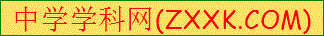_ you?
A. is B. am C.are
( ) 2.I _____ two.
A. am B.is C. are
( ) 3.--_________. –Thank you!
- Please open the door B. Where’s the cake? C. Here you are.
( ) 4. ---Look at the parrot! ---______ lovely![来源:学*科*网Z*X*X*K]
A.What’s B. What C. How
( ) 5. This pencil is _____ you.
A. for B.at C. to [来源:学。科。网]

